SIMATS ENGINEERING
Department of Information Technology
CSA15 – CLOUD COMPUTING AND BIG DATA ANALYTICS
ASSIGNMENT 2 – CO2
Analyse, Evaluate and Validate a Virtualization Architecture for a Multi-Tenant University Private Cloud
CO2: Analyze virtualization architectures to identify performance and security issues in cloud computing environments.
Field | Details | Field | Details
Student Name | M Sanjay Krishna | Register Number | 192525421
Department / Section | B TECH AI&ML | Academic Year / Semester | 2026
Faculty Name | Dr Latha R | Nature of Assignment | Individual
Duration | 1 Week | Total Marks | 50
Submission Date | 4/11/2026 | Evaluation Date
MARK SHEET (Rubric-based evaluation)
Task | Title | Max | Awarded | Evidence / evaluation focus
1 | Characterise the Virtualization Architectures | 5
2 | Identify the Dominant Overhead Source | 2
3 | Build a Quantitative Performance Model | 6
4 | Analyse Performance Under Different Conditions | 4
5 | Security Threat and Vulnerability Analysis | 3
6 | Formulate Isolation–Performance Trade-off | 3
7 | Evaluate Mitigation Strategies | 4
8 | Implement and Test | 4
9 | Record Experimental Performance | 3
10 | Compare Theory with Experiment | 4
11 | Recommend and Defend Final Architecture | 4
12 | Day-4 Design Challenge | 8
 | TOTAL | 50
OVERALL REMARKS
Overall, the assignment reflects good analytical ability, technical understanding and problem-solving skills in cloud computing and virtualization. The proposed architecture balances performance, security, resource efficiency and future scalability. The work can be further strengthened through verified experimental results, consistent benchmark comparisons and practical validation of the recommended security controls.
Student Signature | Faculty Signature | Program Director
M Sanjay
MANDATORY SUBMISSION EVIDENCE CHECK
✓ = Present in documented answer; P = Partly present; X = Missing / not satisfied
Task | Evidence expected | Status | Evaluator note
1 | Three virtualization architectures, layered diagrams and trust boundaries
2 | Dominant overhead source identified and explained for each approach
3 | CPU, memory, I/O, network and density models with assumptions
4 | Best, typical and worst operating-condition analysis
5 | Threat model and architecture-based security comparison
6 | Isolation–performance optimization formulation
7 | Mitigation benefits, residual risks and quantified costs
8 | Reproducible setup and practical tests across selected platforms
9 | Actual comparative measurements, table and two graphs
10 | Theory–experiment comparison and quantitative error analysis
11 | Justified SIS/LMS architecture and growth recommendation
12 | Day-4 external tenants, 3× peaks, live migration and SIS isolation
IMPLEMENTATION EVIDENCE CHAIN
Evidence item | Status | Observation
Architecture diagrams
Performance model
Configuration / scripts
Virtualization experiments
CPU / disk / network / memory tests
Noisy-neighbour experiment
Security validation
Tables and graphs
Theory–experiment consistency
Day-4 design defence
Screenshots
SUBMISSION CHECKLIST (Not Separately Marked)
Requirement | Status
All 12 tasks answered | ☐ Yes ☐ Partly ☐ No
Three virtualization approaches compared | ☐ Yes ☐ Partly ☐ No
Layered diagrams and trust boundaries included | ☐ Yes ☐ Partly ☐ No
Quantitative virtualization models included | ☐ Yes ☐ Partly ☐ No
Threat analysis and mitigations included | ☐ Yes ☐ Partly ☐ No

CLOUD COMPUTING AND BIG DATA
ASSIGNMENT 2
CO2: Analyze virtualization architectures to identify performance and security issues in cloud computing environments.
Assignment Title: Analyse, Evaluate and Validate a Virtualization Architecture for a Multi-Tenant University Private Cloud (Total Marks: 50)
Duration: 1 week
Scenario: EduCloud Virtualization Platform
A university runs a private cloud, EduCloud, in its data centre. EduCloud currently consists of:
- 16 physical hosts, each with 64 CPU cores, 512 GB RAM, NVMe SSD storage and 2 × 25 Gbps NICs
- About 400 virtual machines (VMs) running the Student Information System (SIS), the Learning Management System (LMS), the examination portal, and departmental research workloads
- A shared storage backend and a software-defined virtual network
During semester registration week, users report slow response times and failed logins. A recent internal security audit also found that VMs from different departments share the same physical hosts, that some VMs run outdated guest kernels, and that VM images are copied freely between teams.
You are the cloud architect. You must investigate, model, measure and compare virtualization architectures for EduCloud, identify their performance bottlenecks and security weaknesses, and recommend a design that remains practical as the platform grows.
Design Challenge:
The university now plans to host external research collaborators' big-data workloads (Spark/Hadoop clusters) on the same infrastructure as the SIS. Reevaluate your design under these new multi-tenant conditions.
TASK 1: Characterise the Virtualization Architectures (5 Marks)
Select at least three meaningfully different virtualization approaches from the following, or justify others:
- Type-1 (bare-metal) hypervisor with full virtualization
- Type-2 (hosted) hypervisor
- Hardware-assisted virtualization vs. paravirtualization
- OS-level virtualization (containers)
- Lightweight/micro-VM or sandboxed container runtimes
Two configurations of the same hypervisor will not count as different approaches. Your selection must include at least one VM-based and at least one container-based approach.
For each approach, provide:
- A layered architecture diagram showing the hardware, host OS or hypervisor, guest OS, runtime and application
- The trust boundaries and the component that enforces isolation
- How CPU, memory, storage and network are virtualized
- A brief justification for why this approach is relevant to EduCloud
Evidence expected: Three architecturally distinct approaches with labelled diagrams, resource-virtualization mechanisms, trust boundaries, and justification of selection.
TASK 2: Identify the Dominant Overhead Source (2 Marks)
For each approach, identify the primary source of performance overhead that predominantly limits its performance (for example VM exits/traps, nested or extended page-table walks, virtual I/O emulation, virtual switch processing, or system-call interception).
Discuss:
- What the overhead source is
- Where in the architecture it occurs
- Why it is appropriate as the focus of performance analysis
- How its frequency or cost changes as the number of co-located VMs/containers or the I/O rate increases
Do not simply name a mechanism. Relate it to the behaviour of the architecture.
Evidence expected: A justified dominant-overhead identification for each approach, linked to its resource-virtualization path.
TASK 3: Build a Quantitative Performance Model (6 Marks)
Using the following host parameters, develop an analytical performance model for each approach.
Parameter | Value
Physical cores per host | 64
vCPU:pCPU overcommit ratio | 1:1, 2:1, 4:1, 8:1
RAM per host | 512 GB
Average VM memory demand | 8 GB
Cost of one VM exit (assume) | 1.5 µs
Native system-call cost (assume) | 0.2 µs
Network line rate | 25 Gbps

State and justify any additional assumptions. Derive expressions for:
- CPU: effective per-VM CPU capacity as a function of overcommit ratio and virtualization overhead (including steal time)
- Memory: the maximum number of VMs per host before ballooning, swapping or page-sharing becomes necessary
- I/O and network: effective throughput as a function of the number of VMs sharing the physical device
- Density: the number of VMs/containers a host can support while meeting a stated service-level target (for example, ≤ 10% performance degradation)
Show the mathematical reasoning. Merely quoting overhead percentages from the literature will not receive full credit.
Evidence expected: A clear mathematical derivation for each approach, with stated assumptions, parameter values and worked numerical examples.
TASK 4: Analyse Performance Under Different Operating Conditions (4 Marks)
Analyse how each approach behaves under three conditions:
- Best case: what workload and placement conditions minimise overhead?
- Typical case: for example, registration-week mixed web and database load
- Worst case: for example, noisy-neighbour interference, memory overcommit with swapping, live migration during peak load, or I/O storms
For each, explain what happens inside the virtualization layer, why the overhead changes, and how latency and throughput are affected. A table of numbers alone will not be accepted.
Evidence expected: A justified condition-based analysis supported by your Task 3 model.
TASK 5: Security Threat and Vulnerability Analysis (3 Marks)
Construct a threat model for each approach. Discuss:
- The attack surface (hypervisor, device emulation, shared kernel, management plane, VM images and snapshots, virtual network)
- At least four distinct threat categories, such as VM escape, cross-VM side-channel attacks, hypervisor or container-runtime vulnerabilities, VM sprawl and unpatched guests, image tampering, insecure live migration, and virtual-network sniffing or spoofing
- For each threat, which approach is more or less exposed and why, referring to its architecture and trust boundaries
- The likely impact on the confidentiality, integrity and availability of student records
Evidence expected: A structured threat model mapped to architectural features, with a justified comparison across approaches.
TASK 6: Formulate the Isolation–Performance Trade-off (3 Marks)
Formalise the trade-off between isolation strength and performance/density for EduCloud.
Clearly identify:
- The decision variables (for example, approach chosen, VMs per host, dedicated vs. shared hosts, SMT on/off)
- The objective(s), such as maximising density or minimising cost
- The constraints (for example, performance degradation limit, isolation requirement for SIS, available hosts)
- How these components combine into a cost or decision function
The formulation must follow from your own analysis in Tasks 3 and 5, not from a generic template.
Evidence expected: A clearly defined trade-off model with identified variables, objective and constraints.
TASK 7: Evaluate Mitigation Strategies (4 Marks)
Propose at least three mitigations for the vulnerabilities identified in Task 5. Examples include disabling SMT, kernel page-table isolation, dedicated hosts for sensitive tenants, secure or sandboxed container runtimes, hardware memory encryption, image signing, and micro-segmentation.
For each mitigation, discuss:
- Why it is applicable to the threat
- What residual risk remains
- The performance or density cost, estimated using your Task 3 model
- Whether the trade-off is acceptable for the SIS
Evidence expected: Mitigations evaluated analytically, with their security benefit and quantified performance cost.
TASK 8: Implement and Test (4 Marks)
Build a test environment and experimentally test all selected approaches.
- Platforms: use any open-source stack, for example KVM/QEMU, Xen or VirtualBox, Docker/Podman, and Kata Containers or gVisor. Nested virtualization on a laptop is acceptable if documented.
- Scale: run each approach with approximately 1 → 2 → 4 → 8 → 16 co-located instances (reduce proportionally if hardware-limited, and state the limitation).
- Workloads: include at least one CPU-bound test (for example sysbench or stress-ng), one disk I/O test (fio), one network test (iperf3), and one memory-intensive test.
- Interference test: run at least one noisy-neighbour experiment.
- Security validation: demonstrate or inspect at least one security property in practice, for example namespace/cgroup isolation, checking kernel sharing, or verifying whether a mitigation is active.
Ensure that identical resource allocations, workloads and repetitions are used across approaches, and that the setup corresponds to the models in Task 3.
Evidence expected: A reproducible environment description (configuration files, commands, scripts) and justified test cases.
TASK 9: Record Experimental Performance (3 Marks)
Collect and present data such as:
- Throughput, latency (mean and 95th percentile), CPU steal time, context switches and VM exits where observable
- Instance start-up time and memory footprint per instance
- Performance degradation versus a bare-metal baseline
- Results with and without at least one security mitigation
Present at least one table and two graphs (for example, throughput versus number of instances, and latency under interference). Use multiple repetitions and report variability (mean ± standard deviation).
Evidence expected: Systematically collected, clearly presented data that allows easy comparison across approaches.
TASK 10: Compare Theory with Experiment (4 Marks)
Compare your Task 3 and Task 4 predictions with Task 9 measurements.
Discuss:
- Whether the observed degradation trends agree with your model
- Which approach scales better as co-located instances increase
- Quantitative differences between predicted and measured values, and plausible causes (for example caching effects, hypervisor scheduler behaviour, nested virtualization, laptop hardware, or unmodelled I/O paths)
- Whether any measured result changes your security conclusions from Task 5
Interpret the results; do not simply reproduce tables.
Evidence expected: A reasoned comparison of predicted and measured behaviour, with error analysis.
TASK 11: Recommend and Defend the Final Architecture (4 Marks)
Recommend the virtualization architecture (or hybrid) for EduCloud's SIS and LMS workloads.
Discuss:
- Which approach you recommend and why it is more appropriate than the alternatives
- Its modelled and experimentally observed performance
- Its security posture and residual risks
- Operational costs such as patching, image management, migration and monitoring
- Limitations and trade-offs
- Whether it remains practical as EduCloud grows from 400 to several thousand instances
Your recommendation must rest on your own analysis and experiments. Choosing "the most secure" or "the fastest" option alone is not sufficient.
Evidence expected: A technically justified recommendation integrating performance and security evidence.
DAY-4 DESIGN CHALLENGE
TASK 12: Re-evaluate and Adapt the Design (8 Marks)
Changed Requirement
The university will now host external research collaborators' Spark/Hadoop workloads on EduCloud alongside the SIS. The new conditions are:
- Big-data jobs are I/O- and network-intensive and run for hours
- Registration-week peak load is about 3× normal
- Hosts are sometimes patched using live migration of running VMs
- A data-protection regulation now requires demonstrable isolation of student records from external tenants
You may RETAIN → MODIFY → or REDESIGN your original solution.

A. Impact Analysis (2 Marks)
Discuss what has changed, which original assumptions (trusted tenants, workload mix, I/O profile) no longer hold, and how mixing batch big-data workloads with latency-sensitive SIS workloads changes both the performance and the threat model.
B. Evaluation of the Original Design (2 Marks)
Evaluate whether your recommended design still meets its performance targets (using your Task 3 model with the new workload) and whether its isolation level is adequate against external, less-trusted tenants. Consider whether another architecture could do better overall.
C. Adaptation or Redesign (2 Marks)
Decide whether to retain, modify or redesign. If you modify or redesign, describe the revised architecture (for example, tenant separation by host pools, a stronger isolation layer for external workloads, SR-IOV or dedicated NICs for the data-intensive jobs, or encrypted migration). Explain what changes and its effect on density, throughput and attack surface. If you retain, justify why no change is required.
D. Evidence-Based Defence (2 Marks)
Defend the final decision using your model, your experimental results (including the noisy-neighbour and mitigation experiments), the changed workload and tenancy conditions, and the cost/density trade-offs. The decision must follow logically from the analysis.
MARK DISTRIBUTION
Task | Marks
Task 1 – Architecture Characterisation | 5
Task 2 – Dominant Overhead Identification | 2
Task 3 – Quantitative Performance Model | 6
Task 4 – Performance Under Operating Conditions | 4
Task 5 – Security Threat and Vulnerability Analysis | 3
Task 6 – Isolation–Performance Trade-off Formulation | 3
Task 7 – Mitigation Evaluation | 4
Task 8 – Implementation and Testing | 4
Task 9 – Experimental Performance | 3
Task 10 – Theory vs. Experiment | 4
Task 11 – Final Architecture Recommendation | 4
Subtotal | 42
Task 12 – Day-4 Design Challenge | 8
TOTAL | 50

ASSIGNMENT REPORT
CSA15 – Cloud Computing and Big Data Analytics | Assignment 2 – CO2
Analysis, Evaluation and Validation of a Virtualization Architecture for a Multi-Tenant University Private Cloud (EduCloud)

Honesty and Evidence Statement
This report contains two kinds of numbers. Values produced by the analytical model in Tasks 3, 4, 6 and 7 are model estimates calculated from the parameters given in the brief plus clearly stated assumptions; they are predictions, not measurements. Tables and graphs for Tasks 9 and 10 are provided as recording templates. Every cell or screenshot highlighted in yellow must be replaced with data you actually collect by running the procedure in Task 8 on your own machine. Nothing highlighted should be submitted as a measured result until it has been genuinely measured.

Scenario Summary
EduCloud is a private cloud with 16 hosts (64 cores, 512 GB RAM, NVMe and 2 × 25 Gbps NICs each) running about 400 VMs for the Student Information System (SIS), Learning Management System (LMS), the examination portal and departmental research. During registration week users saw slow responses and failed logins. An audit found mixed-department tenancy on shared hosts, outdated guest kernels and uncontrolled copying of VM images. The task is to compare virtualization architectures, model and test them, and recommend a design that survives growth, including the Day-4 change that adds external Spark/Hadoop tenants.

Common assumptions used throughout
- Host reserve: 16 GB of RAM is kept for the host OS and hypervisor, leaving 496 GB for guests.
- Typical guest: 4 vCPU and 8 GB RAM (the brief’s average memory demand). VM exit cost 1.5 µs and native system call cost 0.2 µs, as given.
- Per-approach constants (exit rate, scheduling penalty γ, memory overhead, network efficiency η) are assumed values listed in Table 3.1. They are plausible engineering figures, chosen so the model can be exercised, and are meant to be replaced or tuned with your own measurements in Task 10.
- Only one 25 Gbps NIC is counted in the I/O model (conservative); bonding both NICs doubles the aggregate.

Report roadmap and mark allocation
Task | Title | Marks | Evidence type
1 | Characterise the Virtualization Architectures | 5 | Diagrams, trust boundaries
2 | Identify the Dominant Overhead Source | 2 | Analysis
3 | Build a Quantitative Performance Model | 6 | Derivations, graphs
4 | Analyse Performance Under Different Operating Conditions | 4 | Analysis
5 | Security Threat and Vulnerability Analysis | 3 | Threat model
6 | Formulate the Isolation–Performance Trade-off | 3 | Formal model
7 | Evaluate Mitigation Strategies | 4 | Analysis, costs
8 | Implement and Test | 4 | Commands, scripts
9 | Record Experimental Performance | 3 | Your measurements
10 | Compare Theory with Experiment | 4 | Error analysis
11 | Recommend and Defend the Final Architecture | 4 | Decision matrix
12 | Day-4 Design Challenge | 8 | Redesign, defence
 | Total | 50

TASK 1: Characterise the Virtualization Architectures
Selection. Three architecturally different approaches are analysed. They differ in where the isolation boundary sits and what enforces it: (A) KVM/QEMU, a Type-1 style hypervisor using hardware-assisted full virtualization (VM-based); (B) Docker/runc containers, OS-level virtualization (container-based); (C) gVisor (runsc), a sandboxed container runtime that places a user-space kernel between the application and the host kernel. Two configurations of one hypervisor were deliberately not used. Kata Containers (micro-VM) is a possible substitute for (C) on hardware that supports nested KVM; gVisor is preferred here because it runs on a laptop without nested virtualization.
Why these three are relevant to EduCloud. The audit shows (i) tenants from different departments share hosts, (ii) guests run outdated kernels, and (iii) images are copied freely. Approach A is the current model (400 VMs). Approach B is the density and start-up benchmark most LMS and research teams will ask for. Approach C is the middle option: container workflow with a much stronger boundary than B.

1.1 Approach A: KVM/QEMU with hardware-assisted full virtualization
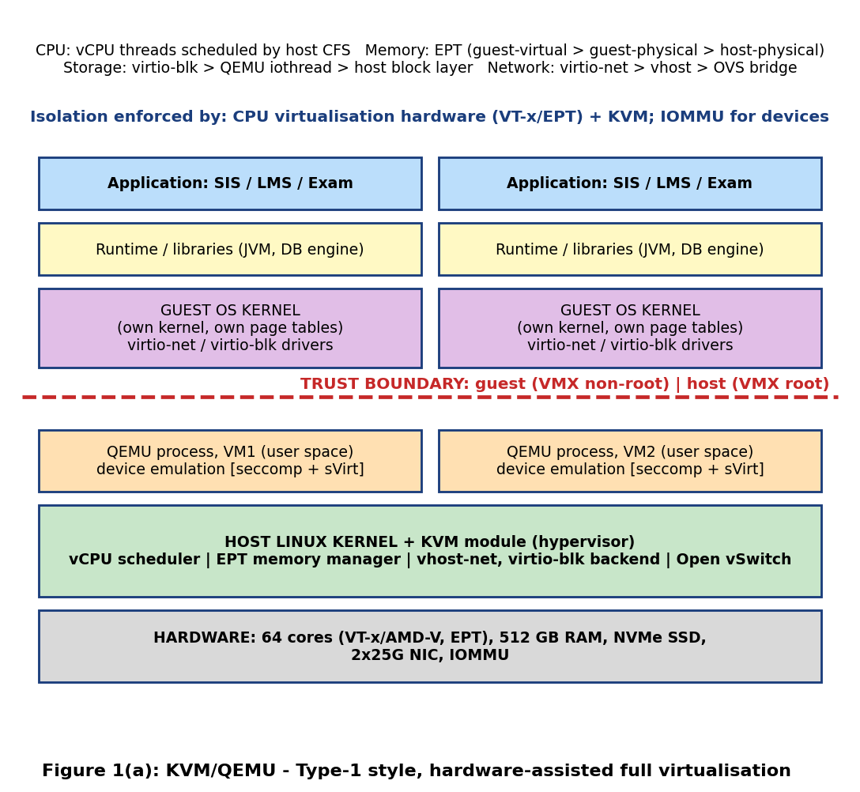
Trust boundary and isolation enforcer. The boundary lies between the guest (VMX non-root mode, own kernel) and the host (VMX root mode). It is enforced by the CPU virtualization hardware (VT-x/EPT) and the KVM module, with the IOMMU protecting devices. QEMU, which emulates devices in user space, sits on the host side but is confined by seccomp and SELinux (sVirt), so a QEMU bug alone does not give full host control.
Resource | How it is virtualized in approach A
CPU | Each vCPU is a host thread. Guest code runs natively; privileged events cause a VM exit to KVM (about 1.5 µs each in this assignment). The host scheduler multiplexes vCPUs over pCPUs (overcommit).
Memory | Two-dimensional translation: guest page tables (GVA to GPA) plus EPT (GPA to HPA). Guest memory is a QEMU process mapping; ballooning, KSM and swapping are host options.
Storage | virtio-blk/virtio-scsi: the guest driver places requests on a virtqueue, the host (QEMU iothread or vhost) submits them to the NVMe or shared backend.
Network | virtio-net with vhost-net: guest kicks a virtqueue (VM exit), a host vhost thread forwards packets to an Open vSwitch or Linux bridge on the 25 Gbps NIC.

1.2 Approach B: OS-level virtualization (Docker/runc containers)
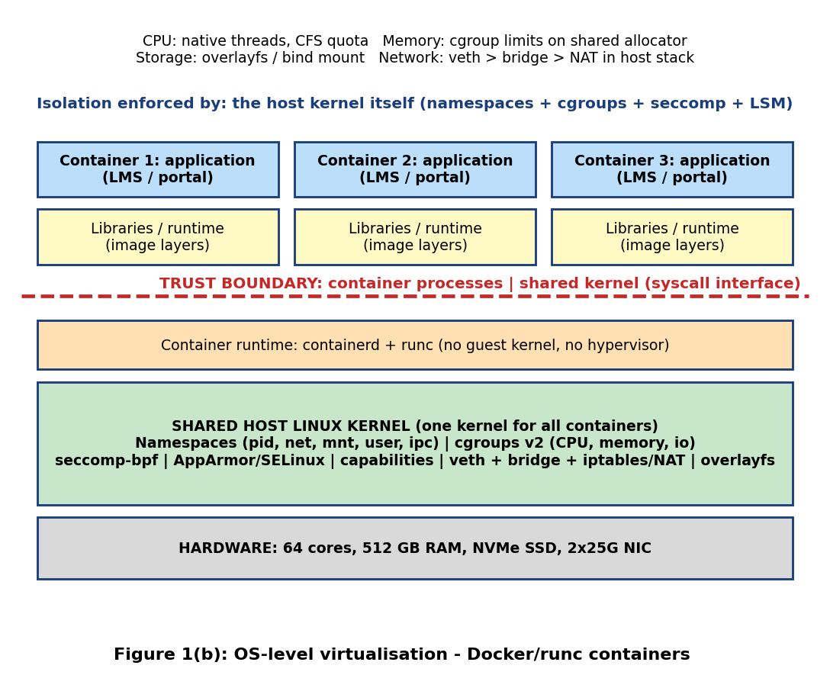
Trust boundary and isolation enforcer. There is no guest kernel. The boundary is the system-call interface between container processes and the single shared host kernel. Isolation is enforced by the kernel itself (namespaces, cgroups, seccomp, AppArmor/SELinux, capabilities). A kernel vulnerability therefore breaks every container on the host.
Resource | How it is virtualized in approach B
CPU | No virtualization: container processes are ordinary threads. cgroup v2 cpu.max/cpu.weight limit and share CPU time through the host CFS scheduler.
Memory | No second translation level. cgroup memory.max accounts and limits memory from the shared page allocator; the page cache is shared.
Storage | overlayfs for image layers, bind mounts or volumes for data; cgroup io.max/io.weight for limits. Requests go straight into the host block layer.
Network | Per-container network namespace connected by a veth pair to a host bridge; iptables/nftables NAT and conntrack run in the host kernel softirq context.

1.3 Approach C: Sandboxed container runtime (gVisor/runsc)
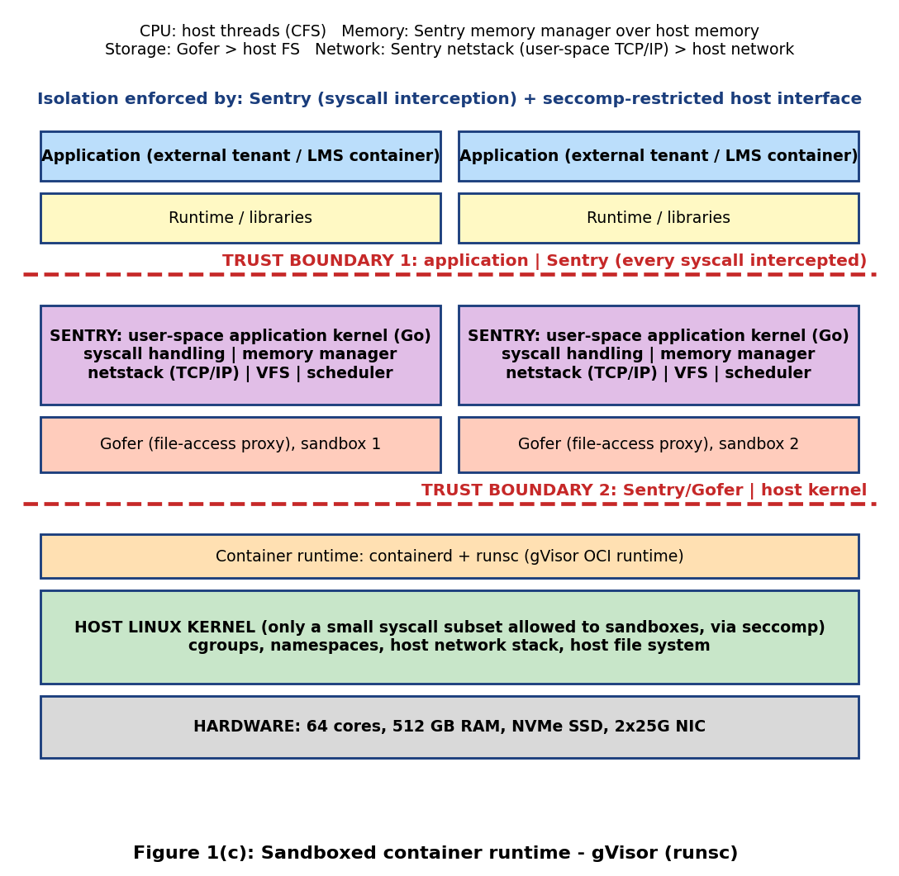
Trust boundaries and isolation enforcer. There are two. Boundary 1 lies between the application and the Sentry, a user-space application kernel that intercepts every system call. Boundary 2 lies between the Sentry/Gofer and the host kernel, which is reached only through a small, seccomp-restricted set of host system calls. The Sentry is the primary enforcer, with the host kernel as a second layer.
Resource | How it is virtualized in approach C
CPU | Application threads run natively on host threads, but each system call is trapped (ptrace/systrap or KVM platform) and executed by the Sentry (assumed 2.0 µs versus 0.2 µs native).
Memory | The Sentry's own memory manager maps application memory over host memory. The application sees an emulated address space; the Sentry itself needs about 150 MB per sandbox (assumption).
Storage | File operations go to a Gofer process over a file protocol, which then performs the host file operation (extra context switches).
Network | The Sentry netstack implements TCP/IP in user space and exchanges frames with the host (or the host network can be passed through for speed).

1.4 Summary of the three approaches
Property | A: KVM/QEMU | B: Docker/runc | C: gVisor
Isolation enforcer | VT-x/EPT + KVM | Host kernel | Sentry + seccomp host interface
Own guest kernel | Yes | No | Emulated (Sentry)
Host attack surface | KVM + QEMU device models | Full syscall interface (300+ calls) | Small host syscall subset
Typical start-up | Seconds to tens of seconds | Under 1 s | Under 1 s
Best use at EduCloud | SIS, exam portal, untrusted tenants | Trusted internal LMS/dev workloads | Untrusted or less-trusted containers

TASK 2: Identify the Dominant Overhead Source
Common view. Pure computation (ALU work, cache-resident loops) runs at native speed in all three approaches. Overhead appears only when execution crosses an isolation boundary. Therefore for each approach the dominant overhead is: crossing frequency multiplied by cost per crossing. The dominant crossing differs because the boundaries differ (Figure 1).
Approach | Dominant overhead | Where it occurs | Frequency driver | Cost per event (assumed)
A: KVM | VM exits (I/O kicks, interrupts, EPT violations, HLT/IPI) | Guest to KVM transition at boundary 1 | Guest I/O rate and timer/IPI rate: e exits/s per vCPU | 1.5 µs per exit
B: Docker | Virtual-network path (veth, bridge, NAT/conntrack) and overlayfs on the shared kernel | Host kernel softirq, between container and NIC | Packet rate and file-op rate | 0.6 µs per packet
C: gVisor | System-call interception by the Sentry | Application to Sentry at boundary 1 | System-call rate σ per second | 2.0 µs per syscall (0.2 native)

A: KVM, VM exits. An exit saves guest state, switches to host mode, handles the event in KVM or QEMU and resumes the guest. The direct cost is the 1.5 µs given in the assignment, and there is an indirect cost because the host code evicts guest cache and TLB entries. With a 20,000 exits/s workload per vCPU, 3% of a core is spent in exits (20,000 × 1.5 µs). It is the right focus because ordinary instructions cost nothing extra, so exits determine the CPU gap between a VM and bare metal. The exit rate grows with the I/O rate (each virtio kick or interrupt can cause an exit) and with overcommit (more timer ticks, IPIs and HLT exits when vCPUs wait). As more VMs are co-located, exits compete for the same host cores and the host vhost/iothread capacity, so the cost per exit can rise through cache pollution, even though the number of exits per VM is unchanged.
B: Docker, virtual-network and shared-kernel I/O path. Containers do not trap, so CPU overhead is almost zero (only seccomp filtering at about 0.03 µs per syscall, assumed). What they add is the per-packet traversal of veth, bridge and iptables/conntrack in the shared host kernel, and overlayfs lookups for files. This is why networking and storage, not CPU, limit containers. The cost grows linearly with packet and file-operation rate, and it grows faster than linearly with the number of containers because the conntrack table, bridge forwarding database and iptables rule chain are shared and lock-protected: rule traversal time grows with the number of container rules.
C: gVisor, system-call interception. Every system call becomes a trap into the Sentry (10 times native, 2.0 µs versus 0.2 µs), and file and network calls additionally go through the Gofer and netstack. This is why syscall-heavy workloads (web servers, databases) suffer while CPU-bound loops do not. The overhead equals σ × 1.8 µs, so it scales directly with the syscall rate: at 50,000 syscalls/s it is 9% of a core, and it reaches the 10% service-level limit at σ = 55,555/s. The number of sandboxes affects it only indirectly (more Sentry threads and Go runtime garbage collection compete for cores).

TASK 3: Build a Quantitative Performance Model

3.1 Assumptions
- Host: P = 64 schedulable physical cores (SMT off, the conservative baseline), M = 512 GB RAM; SMT on is treated later as a +25% throughput factor (γ = 0.25).
- Instance (VM or container): v = 4 vCPUs, memory demand m = 8 GB (given), average vCPU duty cycle u (fraction of time a vCPU wants to run): u = 0.25 normal, 0.5 registration week, 0.75 or 1.0 stress.
- Per-vCPU workload: e = 20,000 VM exits/s and a 1.5% extra TLB/EPT walk cost (ε) for the mixed web+database load; σ = 50,000 system calls/s per instance.
- Given constants: t_exit = 1.5 µs, t_sys = 0.2 µs, line rate B = 25 Gbps. Assumed: gVisor syscall cost t_gv = 2.0 µs; seccomp extra cost 0.03 µs/syscall; Ethernet framing efficiency η = 0.975 (1500-byte frames, 12,000 bits per packet).
- Fixed memory: host reserve 16 GB (KVM) or 12 GB (containers); per-instance overhead 0.30 GB (QEMU process and page tables), 0.02 GB (container runtime), 0.15 GB (Sentry); KSM can share 15% of guest memory if enabled.
- Per-instance data path limit (CPU cost per packet or I/O): t_pkt = 0.9 µs (KVM vhost), 0.6 µs (Docker), 4.0 µs (gVisor netstack); shared NVMe device = 700k IOPS (4 KiB random); per-instance I/O path limit 150k IOPS (KVM), 400k (Docker), 40k (gVisor).
- CPU time slice q = 3 ms (for wake-up delay estimates). Service-level target (SLO): at most 10% degradation relative to bare metal.

3.2 CPU model
Let r be the vCPU:pCPU overcommit ratio (r = n·v / P for n instances). If each vCPU wants the CPU a fraction u of the time, the demand per pCPU is u·r. When u·r ≤ 1 all demand is met; otherwise each vCPU gets only a fraction 1/(u·r) of what it wants. Steal time (the time a runnable vCPU waits for a pCPU) is therefore
s(u, r) = max(0, 1 − 1/(u·r))
The virtualization overhead fraction is o_A = e·t_exit + ε for KVM, o_B = σ·Δ_sec for containers (Δ_sec = 0.03 µs), and o_C = σ·(t_gv − t_sys) for gVisor. The delivered capacity of one vCPU, as a fraction of what a bare-metal core would deliver for the same demand, is
C_eff = (1 − o) · min(1, 1/(u·r)), so the capacity per VM is C_VM = v · C_eff core-equivalents.
For a fully busy vCPU (u = 1) this reduces to (1 − o)/r. Worked values: o_A = 20,000 × 1.5 µs + 1.5% = 3% + 1.5% = 4.5%; o_B = 50,000 × 0.03 µs = 0.15%; o_C = 50,000 × 1.8 µs = 9%.
r | Steal at u = 1 | KVM capacity/vCPU at u = 1, (1−o_A)/r | Steal at u = 0.25 | Worst wake-up delay (r−1)·q
1:1 | 0% | 0.955 | 0% | 0 ms
2:1 | 50% | 0.478 | 0% | 3 ms
4:1 | 75% | 0.239 | 0% (u·r = 1) | 9 ms
8:1 | 87.5% | 0.119 | 50% | 21 ms

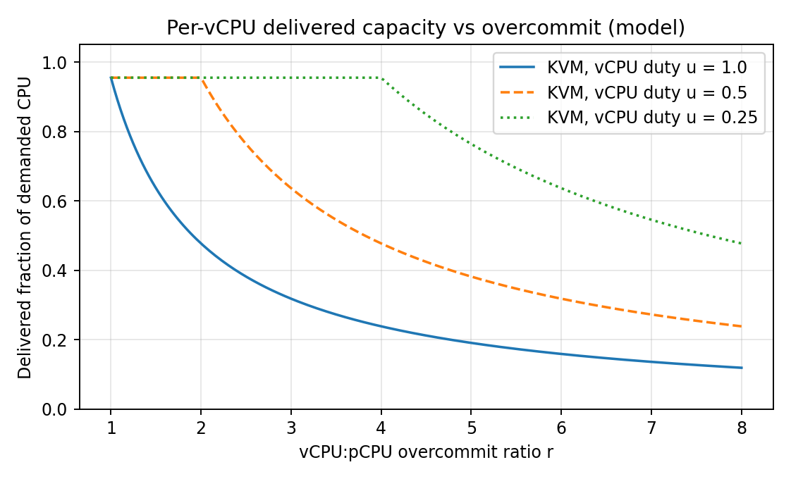
Figure 2: Delivered CPU per vCPU versus overcommit ratio (model, KVM, o = 4.5%).
Reading. At the average duty cycle observed on EduCloud (about 15%) even 4:1 is free of steal, but when duty cycles rise to 25% (4:1) the system is at the knee, and at 8:1 half of the demand is lost. Registration week therefore needs r ≤ 1/u: for u = 0.5 at most 2:1.

3.3 Memory model
Memory is exhausted before swapping or ballooning is needed when the sum of instance footprints is below the usable RAM:
N_mem = floor( (M − M_host) / (m·(1 − k) + m_ovh) )
where k is the shared-page fraction (k = 0 without KSM). Values: KVM: (512 − 16)/(8 + 0.30) = 496/8.3 = 59.8, so 59 VMs; with KSM (k = 0.15): 496/(8 × 0.85 + 0.30 = 7.1) ≈ 70 VMs. Docker: (512 − 12)/(8 + 0.02) = 62.3, so 62. gVisor: 500/(8 + 0.15) = 61.3, so 61. Beyond these numbers the host must balloon, share pages or swap. If a fraction p of accesses fault to swap on NVMe (about 100 µs against 0.1 µs for DRAM), the mean access time is (1 − p)·0.1 + p·100 µs, so p = 1% gives about 1.1 µs, an 11× slowdown, which is why swapping is treated as a worst case in Task 4.
Note on the current platform: 400 VMs over 16 hosts is 25 VMs per host, i.e. about 100 vCPUs per 64 cores (1.6:1) and about 207 GB per 512 GB (40%). Average capacity is therefore not the problem; the registration-week slowdown must come from peaks in u, noisy neighbours and shared I/O paths.

3.4 I/O and network model
For n instances sharing the 25 Gbps NIC, the usable line rate is B_eff = B·η = 24.4 Gbps. Each instance is also limited by its own data-path speed T_path = L/t_pkt (L = 12,000 bits). The per-instance throughput is the smaller of the fair share and the path limit:
T_net(n) = min( T_path , B_eff / n )
T_path = 12,000 / 0.9 µs = 13.3 Gbps (KVM), 20 Gbps (Docker), 3.0 Gbps (gVisor). The same form is used for storage with IOPS: IOPS(n) = min( q_path , 700k / n ).
Instances n | KVM Gbps | Docker Gbps | gVisor Gbps | KVM kIOPS | Docker kIOPS | gVisor kIOPS
1 | 13.3 | 20.0 | 3.0 | 150 | 400 | 40
2 | 12.2 | 12.2 | 3.0 | 150 | 350 | 40
4 | 6.1 | 6.1 | 3.0 | 150 | 175 | 40
8 | 3.05 | 3.05 | 3.0 | 87.5 | 87.5 | 40
16 | 1.52 | 1.52 | 1.52 | 43.8 | 43.8 | 40

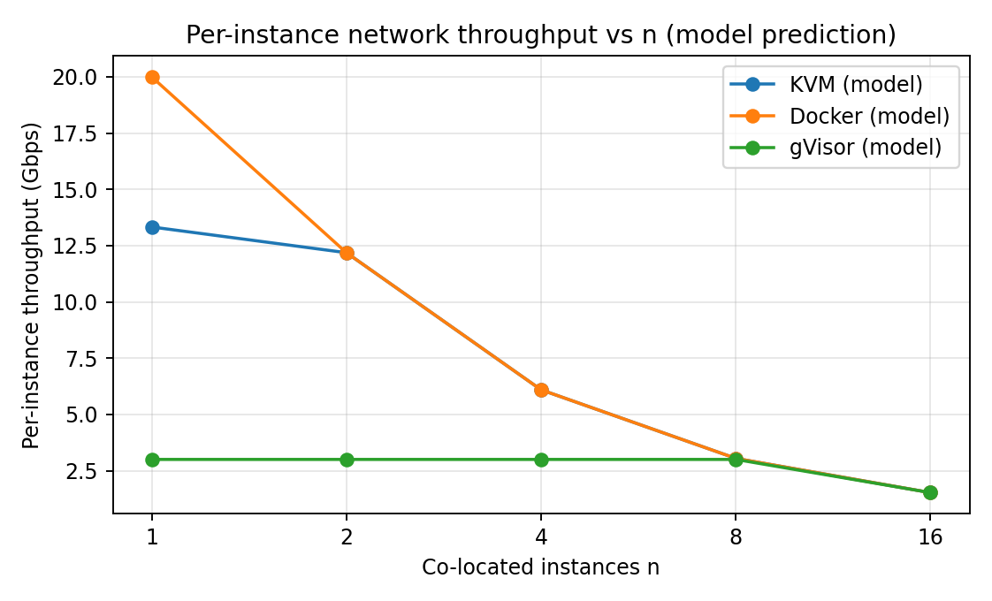
Figure 3: Predicted per-instance network throughput versus co-located instances.
Reading. Containers lead when few instances share the device (cheapest path), but once the shared device saturates (n ≥ 4 for network) all approaches converge to B_eff/n: the physical device, not the virtualization layer, becomes the bottleneck. gVisor is limited by its own path for n < 16.

3.5 Density model (≤ 10% degradation)
Degradation relative to bare metal is D = 1 − C_eff. Requiring D ≤ 0.10 gives (1 − o)·min(1, 1/(u·r)) ≥ 0.90, hence the largest allowed overcommit and the CPU-limited density are
r_max = (1 − o)/(0.90·u), N_cpu = floor( r_max · P / v ), N_max = min( N_cpu , N_mem )
Worked example for KVM at u = 0.5: r_max = 0.955/(0.9 × 0.5) = 2.12, N_cpu = floor(2.12 × 64/4) = 33; at u = 0.25: r_max = 4.24, N_cpu = 67, but N_mem = 59, so N_max = 59 (memory-bound).
Duty cycle u | KVM N_max | Docker N_max | gVisor N_max | Binding limit
0.25 (normal) | 59 | 62 | 61 | Memory
0.50 (registration) | 33 | 35 | 32 | CPU
0.75 (stress) | 22 | 23 | 21 | CPU
1.00 (saturated) | 16 | 17 | 16 | CPU

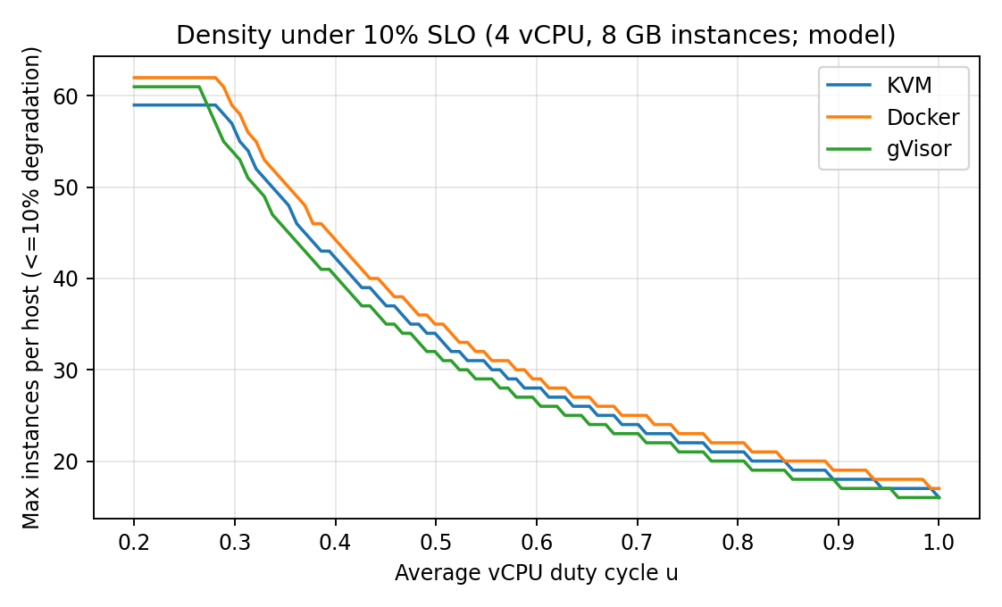
Figure 4: Instances per host that meet the 10% degradation target, versus duty cycle (model).
Break-even workloads. The 10% SLO fails for KVM when e > (0.10 − 0.015)/1.5 µs = 56,667 exits/s per vCPU, and for gVisor when σ > 0.10/1.8 µs = 55,555 syscalls/s, regardless of density. SMT on adds 25% throughput: for KVM at u = 0.5, N_cpu becomes floor(2.12 × 80/4) = 42 instead of 33.

TASK 4: Analyse Performance Under Different Operating Conditions

4.1 Best case
Conditions: CPU-bound or cache-resident work, vCPUs pinned to dedicated cores, huge pages, a single instance per device (n = 1), SR-IOV or vhost with polling, low overcommit (r ≤ 1). KVM: the exit rate falls to about 2,000/s and huge pages cut the extra EPT walk to 0.5%, so o_A = 0.3% + 0.5% = 0.8%. The hardware executes guest code natively and most TLB misses are served by a short walk; latency is within 1–2% of bare metal. Docker: o_B ≈ 0.05% and throughput equals native for CPU; network is the fastest path (20 Gbps for one container). gVisor: for a compute loop with 5,000 syscalls/s o_C = 0.9%, so CPU-bound work is almost unaffected; but I/O-bound work stays slow because every call still crosses the Sentry.

4.2 Typical case: registration-week mixed web and database load
Conditions: u = 0.5, e = 20,000/s, σ = 50,000/s, 25–33 instances per host, mixed small requests and database queries. Inside the layer: KVM spends 3% of each vCPU in exits plus 1.5% in 2-D walks (o = 4.5%); host cores run vhost threads for every virtio kick; at r = 2 the CPU is exactly saturated (u·r = 1) so any burst creates steal and queueing delay of up to q = 3 ms. Docker runs system calls natively (0.2 µs), so the CPU cost is almost nil, but every request passes the shared veth/bridge/conntrack path (0.6 µs per packet); throughput is high, but tail latency depends on softirq load on shared cores. gVisor pays 9% CPU on syscalls and has the lowest per-instance network ceiling (3 Gbps). Effect: KVM and Docker meet the 10% SLO up to 33 and 35 instances; gVisor meets it only up to 32 and has no margin (a 10% rise in syscall rate breaks the SLO). Mean latency rises by about the overhead (4.5%, 0.15%, 9%) but p95 rises more because of scheduler waits.

4.3 Worst cases
Worst-case condition | What happens inside the virtualization layer | Effect on latency and throughput (from the Task 3 model)
Noisy neighbour (CPU or I/O storm) | KVM: neighbour vCPUs compete for the same pCPUs and last-level cache; shared NVMe queue fills. Docker: neighbour shares kernel locks, page cache and softirq. gVisor: neighbour shares host threads; Sentry per sandbox limits kernel-level leakage. | Shared-device latency scales as 1/(1 − ρ): a victim at 30% load facing a neighbour that brings the device to 90% load sees (1 − 0.3)/(1 − 0.9) = 7× latency (Figure 6 in Task 9). A cap at 40% limits inflation to about 2.3×.
Memory overcommit with swapping | Host reclaims guest or container pages and pages them to NVMe; for VMs the guest cannot know which pages are swapped (double paging); for containers the cgroup is throttled and OOM kills may occur. | With 1% swap faults the mean access time rises about 11× (Section 3.3); throughput of memory-bound work falls to about 1/11.
Live migration during peak load | KVM only: pre-copy iteratively sends dirty pages, then pauses the VM for the final set. Needs bandwidth B_mig and consumes host CPU for dirty-page tracking and copying. | Migration time T = M/(B_mig − D): for an 8 GB VM, B_mig = 1.25 GB/s (10 Gbps): D = 0.5 GB/s gives 10.7 s, D = 1.0 GB/s gives 32 s, D ≥ 1.25 GB/s never converges (needs throttling or post-copy). Guest performance dips by the dirty-tracking cost during that time.
I/O storm | KVM: exit and vhost thread rate rises, o_A can reach 100,000 × 1.5 µs = 15% (violates the SLO). Docker: conntrack and bridge saturate softirq cores. gVisor: Sentry and Gofer queues saturate first (40k IOPS ceiling). | Per-instance throughput falls to B_eff/n or IOPS/n; p95 latency grows steeply near saturation. gVisor degrades first, Docker last.
Over-subscribed CPU (r = 8) | vCPUs wait in the run queue: steal 50–87%. | Worst wake-up delay (r − 1)·q = 21 ms; capacity per vCPU falls to 0.12 of demand at u = 1.

Overall. Best-case differences between approaches are small. Under typical load, differences are dominated by each approach's own crossing cost (exits for KVM, shared-kernel path for Docker, syscalls for gVisor). In worst cases shared physical resources (NVMe, NIC, cache, memory) dominate and the virtualization layer matters mainly through how well it can cap and isolate a misbehaving tenant.

TASK 5: Security Threat and Vulnerability Analysis

5.1 Attack surface of each approach
Surface | A: KVM/QEMU | B: Docker/runc | C: gVisor
Hypervisor / kernel | KVM module in host kernel (small, well-audited) | Entire host kernel (300+ syscalls reachable) | Sentry (memory-safe Go) plus about a few dozen allowed host syscalls
Device emulation | QEMU/virtio device models (large C code base) | None (host drivers directly) | Gofer and netstack in user space
Shared kernel | No (each VM has its own guest kernel) | Yes, the main weakness | Partly: host kernel still shared, but behind Sentry
Management plane | libvirt/OpenStack API, QEMU monitor | Docker daemon socket, orchestrator API (root-equivalent) | Same as Docker plus runsc
Images and snapshots | Large disk images, snapshots hold full memory | Layered images from registries | Same as Docker
Virtual network | OVS/Linux bridge, VXLAN overlay | Docker bridge, shared L2, default CAP_NET_RAW | Sentry netstack filters raw access

5.2 Threat categories and relative exposure
Exposure levels: L = low, M = medium, H = high. Exposure is judged from the architecture and trust boundaries in Figure 1.
Threat | A: KVM | B: Docker | C: gVisor | Why (architecture)
1. VM or container escape | L–M | H | L | B: one shared kernel, so any kernel or runc bug reaches the host (examples: runc CVE-2019-5736, Dirty Pipe CVE-2022-0847). A: attacker must find a hardware-virtualization, KVM or QEMU device-model bug (for example VENOM, CVE-2015-3456). C: the host kernel is reached only through a few filtered calls.
2. Cross-VM side channels (Spectre, MDS, L1TF, cache timing) | M–H | H | M–H | All share cores and caches. A: reduced when SMT is off and hosts are dedicated. B: same kernel and same cores; page cache is shared too. C: same hardware, but fewer shared kernel structures.
3. Hypervisor/runtime vulnerabilities and unpatched guests | M | M | M | A: outdated guest kernels (found in the audit) compromise only that VM unless combined with an escape, but each VM must be patched separately (400 kernels). B: the single host kernel is patched once, but containers must be restarted. C: Sentry and runsc updates, no guest kernel to patch.
4. VM sprawl and image tampering | H | M | M | A: large, unsigned images copied freely between teams (audit finding), snapshots contain secrets and memory. B/C: content-addressed layers and signing (cosign) are available but must be enforced.
5. Insecure live migration | H | n/a | n/a | A: the guest memory (which holds student records) crosses the network; unencrypted pre-copy exposes it to sniffing and allows tampering. Containers are normally restarted, not live-migrated.
6. Virtual-network sniffing and spoofing | M | H | M | B: containers on one bridge share L2 and default capabilities include raw sockets (ARP spoofing). A: shared OVS bridge, but VLAN/VXLAN and port security are available. C: Sentry netstack restricts raw traffic.

5.3 Impact on confidentiality, integrity and availability of student records
- Confidentiality: escape (1), side channels (2) and migration sniffing (5) let one tenant read another's memory or disk, for example SIS grade or fee records. Highest for B (shared kernel) and for A during unencrypted migration.
- Integrity: image tampering (4), network spoofing (6) and an escape with write access can alter records or inject malicious code into a golden image used for the SIS.
- Availability: a noisy or malicious neighbour, a kernel crash affecting all containers on a host (B), a hypervisor failure, or an unpatched guest being compromised can cause the registration-week failures reported. Availability risk from shared-kernel failure is highest for B.
Link to the audit. Shared hosts between departments are threats 1, 2 and 6; outdated guest kernels are threat 3; free copying of images is threat 4. Threat 5 is a risk that arises when live migration is used for patching (and becomes important in Task 12).

TASK 6: Formulate the Isolation–Performance Trade-off
The formulation uses the classes of workload in EduCloud: c ∈ {SIS, EXAM, LMS, RES (internal research), EXT (external collaborators, Task 12)} with instance counts N_c (e.g. 60, 60, 80, 200, 0 for the 400 VMs), duty cycles u_c, and the Task 3 and Task 5 results.

6.1 Decision variables
- a_c ∈ {A (KVM), B (Docker), C (gVisor)}: virtualization approach for class c.
- n_c: instances per host (density) for class c.
- d_c ∈ {0, 1}: 1 if class c runs on dedicated hosts (no co-residency with other classes).
- z_c ∈ {0, 1}: SMT on (1) or off (0).
- m_c ⊆ {image signing, encrypted migration, micro-segmentation, memory encryption}: mitigation set.

6.2 Objective and decision function
Minimise the total of hardware cost and weighted residual security risk:
J = c_h · Σ_c ⌈ N_c / n_c ⌉ + λ · Σ_c w_c · R_c(a_c, d_c, z_c, m_c)
where c_h is the cost of one host (J is measured in host-equivalents, c_h = 1), w_c is the criticality of class c (SIS = 3, LMS = 2, RES = 1), λ converts risk points into host-equivalents (here 0.2), and R_c = Σ over the six threats of exposure scores (L = 1, M = 2, H = 3) from Task 5, reduced by mitigations (for example SMT off lowers threat 2, signing lowers threat 4, encrypted migration lowers threat 5, micro-segmentation lowers threat 6).

6.3 Constraints
- Performance (from Task 3): n_c ≤ N_max(a_c, u_c, z_c) = min(N_cpu, N_mem), which guarantees degradation D_c ≤ δ_c, with δ_SIS = δ_LMS = 10% and δ_RES = 20%.
- Workload feasibility (Task 3 break-even): if a_c = A then e_c ≤ 56,667 exits/s per vCPU; if a_c = C then σ_c ≤ 55,555 syscalls/s.
- Isolation for SIS (Task 5): a_SIS ∈ {A, C} and d_SIS = 1 and z_SIS = 0 (or an equivalent mitigation); no untrusted tenant on any host that runs the SIS.
- Resources: Σ_c ⌈ N_c / n_c ⌉ ≤ H_avail (16 hosts today, growth budget later); memory fits (n_c·m ≤ M − M_host).
- Integrality and migration policy: n_c integer; live migration only within one trust pool and encrypted.

6.4 Worked evaluation for the SIS + exam pool (120 instances, u = 0.5)
Candidate | Hosts H | Risk R (sum of 6 threats) | J = H + 0.2 × w × R, with w = 3 | Feasible?
P1: Docker, shared hosts, no mitigation | ⌈120/35⌉ = 4 | 3+3+2+2+0+3 = 13 | 4 + 0.2×3×13 = 11.8 | No: violates SIS isolation constraint
P2: KVM, shared hosts, no mitigation | ⌈120/33⌉ = 4 | 1+3+2+3+3+2 = 14 | 4 + 8.4 = 12.4 | No: shared hosts
P3: KVM, dedicated, SMT off, signed images, encrypted migration, micro-segmentation | ⌈120/33⌉ = 4 | 1+1+2+1+1+1 = 7 | 4 + 4.2 = 8.2 | Yes
P4: gVisor, dedicated, SMT off, signed, micro-segmentation | ⌈120/32⌉ = 4 | 1+1+2+1+0+1 = 6 | 4 + 3.6 = 7.6 | Only if σ ≤ 55,555/s; SIS database at about 50,000/s has almost no margin and 3 Gbps network ceiling

P3 is selected: it is the cheapest feasible and robust design. P4 has a slightly lower J, but it is rejected because its SLO margin is under 10% (Task 3 break-even) and a modest rise in syscall rate breaks the target. This shows how the performance constraint, not just the risk score, shapes the decision.

TASK 7: Evaluate Mitigation Strategies
Mitigation | Threat addressed and why applicable | Residual risk | Quantified cost (Task 3 model) | Acceptable for SIS?
M1: Disable SMT (and use core scheduling) on SIS hosts | Threat 2: removes cross-thread leakage (MDS/L1TF-type) between sibling hyperthreads | Cross-core LLC and memory-bus channels, other transient-execution bugs | SMT gives +25%: capacity factor 1/1.25 = 0.8. KVM N_cpu at u = 0.5 falls 42 → 33 (−21%); SIS+exam pool 120 VMs needs 4 hosts instead of 3 (+1) | Yes: SIS is latency-sensitive, extra host is affordable
M2: Dedicated host pool for SIS (and separate pool for external tenants) | Threats 1, 2, 6: no co-resident untrusted tenant, so escape or side channel has no attacker to start from | Management plane, shared storage and network if not also separated | Loss of statistical multiplexing: pooled 9 hosts (n = 45) versus segregated 4 + 3 + 4 = 11 hosts (+22%) | Yes: required by audit and by Task 12 regulation
M3: Sandboxed runtime (gVisor) for container workloads | Threat 1 for containers: kernel bug not reachable directly | Sentry bugs, side channels, host kernel | o drops from 0.15% to 9%; N_max at u = 0.5: 35 → 32 (−9%); per-container network at n = 1: 20 → 3 Gbps | Yes for LMS/external containers; no for SIS database if σ > 55,555/s
M4: Image signing, scanning, golden images, TTL for VM images | Threats 3 and 4: only approved, patched images can start; stops free copying | Signed but vulnerable image; compromised signing key | Negligible run-time cost (verification at start-up, under 1 s); operational cost of a build pipeline | Yes
M5: Encrypted live migration (TLS/IPsec), only inside a trust pool | Threat 5: memory with student records is not readable or modifiable on the wire | Compromised endpoint hosts | AES-GCM at an assumed 2 GB/s per core: a 1.25 GB/s stream costs 0.63 core, i.e. 1% of 64 cores, migration time unchanged | Yes
M6: Micro-segmentation (per-app rules in OVS) | Threat 6: spoofing and sniffing between tenants and apps | Compromised app inside one segment | Extra 0.1 µs per packet: KVM t_pkt 0.9 → 1.0 µs, per-VM cap 13.3 → 12 Gbps (−10%) at n = 1; no change for n ≥ 2 (line-rate bound) | Yes
M7: Hardware memory encryption (AMD SEV-SNP / Intel TDX), if the CPUs support it | Hypervisor or host-admin reading guest memory; strengthens regulation evidence | Side channels, availability attacks | Assumed +5% overhead: o_A = 9.5%; N_max at u = 0.5: 33 → 32 (−3%) | Yes, if hardware available

Combined effect for the SIS pool (M1 + M2 + M4 + M5 + M6). On the SMT-off baseline density stays at 33 per host; compared with a shared SMT-on pool (42 per host) it is 21% lower. Network per-VM cap falls 10% at n = 1. The combined risk index falls from 14 (P2) to 7 (P3), that is a 50% reduction for about one extra host. The trade-off is acceptable for the SIS.

TASK 8: Implement and Test
Honesty note. The scripts below are complete and reproducible, but they must be run on your machine. I could not run KVM, Docker or gVisor tests in my environment, so no measured numbers are claimed anywhere in this document. Task 9 and Task 10 contain empty measured columns and instructions to fill them from your own runs.

8.1 Platforms and environment
Item | Specification (edit to match your machine)
Host | Ubuntu 24.04 LTS on a laptop or VM; record CPU model (lscpu), cores C_lab, RAM, SSD type, kernel version
Approach A (VM) | KVM/QEMU with libvirt, Ubuntu cloud image clones, virtio disk and virtio-net; nested virtualization if the host itself is a VM (document it; nested exits are several times more expensive)
Approach B (container) | Docker Engine with runc, same Ubuntu base image, --cpus and --memory limits
Approach C (sandbox) | Docker with the gVisor runsc runtime (systrap platform), identical limits
Instance size | 1 vCPU / 1 GB RAM per instance (proportionally scaled from 4 vCPU / 8 GB), 5 repetitions
Scale | n = 1, 2, 4, 8, 16 instances. If the machine has C_lab cores, state the resulting overcommit r_lab = n/C_lab; if 16 instances do not fit, stop at 8 and state the limitation
Controls | Same image, same limits, same workloads and repetitions; run on AC power, performance governor, close other apps; discard the first run as warm-up

8.2 Preparation commands
# tools and runtimes
sudo apt update && sudo apt install -y qemu-kvm libvirt-daemon-system virtinst docker.io \
sysbench fio iperf3 stress-ng sysstat linux-tools-common
# gVisor (follow https://gvisor.dev/docs/user_guide/install/), then:
sudo runsc install && sudo systemctl restart docker

# benchmark image used by approaches B and C (Dockerfile)
# FROM ubuntu:24.04
# RUN apt-get update && apt-get install -y sysbench fio iperf3 stress-ng
docker build -t edubench .

# approach A: create 16 clones of one prepared cloud image (vm1 ... vm16) with virt-install,
# each --vcpus 1 --memory 1024, virtio disk and network, ssh key installed
iperf3 -s -D # iperf3 server on the host (use a second NIC or loopback and state which)

8.3 Benchmark script (run_bench.sh)
#!/bin/bash
# usage: ./run_bench.sh <kvm|docker|gvisor> <n> <rep> output appended to results.csv
A=$1; N=$2; R=$3; OUT=results.csv; SRV=192.168.122.1
CPU='sysbench cpu --threads=1 --time=20 run | grep "events per second" | awk "{print \$4}"'
MEM='sysbench memory --memory-block-size=1M --memory-total-size=20G --threads=1 run | grep MiB/sec | sed "s/.*(\(.*\) MiB.*/\1/"'
DSK='fio --name=rr --filename=/tmp/f --size=1G --rw=randread --bs=4k --iodepth=32 --ioengine=libaio \
--direct=1 --runtime=20 --time_based --output-format=json | jq ".jobs[0].read.iops"'
NET='iperf3 -c '$SRV' -t 20 -J | jq ".end.sum_received.bits_per_second/1e9"'

run_one() { # $1 = instance index, $2 = metric name, $3 = command
case $A in
kvm) val=$(ssh -o StrictHostKeyChecking=no ubuntu@vm$1 "$3") ;;
docker) val=$(docker exec b$1 bash -c "$3") ;;
gvisor) val=$(docker exec b$1 bash -c "$3") ;;
esac
echo "$A,$N,$R,$2,$1,$val" >> $OUT
}

# start instances and measure start-up time
START=$(date +%s.%N)
for i in $(seq 1 $N); do
case $A in
kvm) virsh start vm$i >/dev/null ;;
docker) docker run -d --name b$i --cpus=1 --memory=1g edubench sleep infinity >/dev/null ;;
gvisor) docker run -d --runtime=runsc --name b$i --cpus=1 --memory=1g edubench sleep infinity >/dev/null ;;
esac
done
# (for kvm wait until ssh answers on every VM before stopping the timer)
echo "$A,$N,$R,startup_s,all,$(echo "$(date +%s.%N) - $START" | bc)" >> $OUT

for m in cpu mem dsk net; do
cmd=${m^^}; for i in $(seq 1 $N); do run_one $i $m "${!cmd}" & done; wait # all instances in parallel
done

# memory footprint per instance (MB)
case $A in kvm) ps -C qemu-system-x86_64 -o rss= | awk '{s+=$1} END{print s/1024/'$N'}' ;;
*) docker stats --no-stream --format '{{.MemUsage}}' ;; esac

# cleanup
case $A in kvm) for i in $(seq 1 $N); do virsh destroy vm$i; done ;;
*) docker rm -f $(docker ps -aq) ;; esac

Run for each approach and each n: for A in kvm docker gvisor; do for n in 1 2 4 8 16; do for r in 1 2 3 4 5; do ./run_bench.sh $A $n $r; done; done; done. Latency (mean and p95) comes from fio (clat percentiles, add --lat_percentiles=1) or from wrk/hey against a small web service, and CPU steal, context switches and exits are collected as in 8.5.

8.4 Noisy-neighbour experiment
# victim = instance 1 (measure fio 4k random-read latency p95 and sysbench cpu events/s)
# neighbour = instance 2 runs a storm; same limits and same host cores for every approach
# baseline (no neighbour): run the victim fio/sysbench alone -> L0
# storm: neighbour: fio --rw=randwrite --bs=4k --iodepth=128 --numjobs=4 \
# --direct=1 --runtime=60 --time_based --filename=/tmp/n
# neighbour: stress-ng --cpu 2 --vm 1 --vm-bytes 80% --timeout 60s
# with mitigation: docker: --device-write-iops /dev/nvme0n1:20000 --cpuset-cpus=...
# kvm: virsh blkdeviotune vm2 vda --total-iops-sec 20000; vcpupin
# latency inflation = p95(with neighbour) / p95(baseline), 5 repetitions each

8.5 Metrics collection and security validation
# CPU steal and context switches (inside VMs) and on host
mpstat -P ALL 1 20 > mpstat.txt # %steal column (VMs); %usr/%sys on host
pidstat -w 1 20 > ctxsw.txt # context switches
sudo perf kvm stat live -d 20 # VM exits by reason (host, approach A)

# security validation 1: kernel sharing
uname -r # on host
docker run --rm edubench uname -r # approach B: identical to host (shared kernel)
docker run --rm --runtime=runsc edubench uname -r # approach C: different (Sentry emulated kernel)
ssh ubuntu@vm1 uname -r # approach A: own guest kernel

# security validation 2: namespace and cgroup isolation
docker run --rm edubench bash -c 'ps aux | wc -l; cat /proc/self/cgroup; cat /sys/fs/cgroup/cpu.max'
sudo lsns -t pid -t net -t mnt # one namespace set per container

# security validation 3: mitigation status
cat /sys/devices/system/cpu/smt/active # 1 = SMT on
grep . /sys/devices/system/cpu/vulnerabilities/* # mds, l1tf, meltdown, spectre status
echo off | sudo tee /sys/devices/system/cpu/smt/control # M1 on/off, then rerun the CPU test

Limitations to state in your report: laptop core count and thermal throttling; nested virtualization (every exit is several times more costly, so approach A will look worse than on bare metal); 1 GB instances instead of 8 GB; loopback or Wi-Fi networking instead of 25 Gbps; no shared storage backend; small n. Reduce n proportionally, keep the same r_lab for all approaches, and compute the model with your own parameters (script in Section 9.4).

TASK 9: Record Experimental Performance
Status of this section. The model-predicted columns below were computed from Task 3. The measured columns are left empty on purpose: they must be filled from your own runs of the Task 8 scripts (mean ± standard deviation over 5 repetitions). Entering numbers that were not measured would be fabrication, and a viva would expose it. The analysis script in Section 9.4 generates the summary table and Figures 5 and 6 from results.csv automatically.

9.1 Data to be collected
- Throughput: sysbench CPU (events/s), sysbench memory (MiB/s), fio random-read IOPS, iperf3 Gbps, for n = 1, 2, 4, 8, 16.
- Latency: mean and 95th percentile (fio clat percentiles or a small web service driven by wrk/hey).
- CPU steal (mpstat), context switches (pidstat -w), VM exits (perf kvm stat, approach A only).
- Start-up time for n instances, and memory footprint per instance (RSS of qemu, docker stats).
- Degradation versus a bare-metal baseline: D = (X_bare − X_virt)/X_bare for each metric.
- With and without one mitigation: SMT off (M1) and, if possible, a cgroup/iotune cap (noisy-neighbour mitigation).

9.2 Results tables (fill the measured columns)
Table 9.1: Throughput and latency versus number of instances (mean ± SD of 5 repetitions).
Approach | n | CPU (events/s) | Memory (MiB/s) | Disk (IOPS) | Latency mean / p95 (ms) | Model net per instance (Gbps) | Measured net (Gbps)
A: KVM | 1 |  |  |  | / | 13.3
B: Docker | 1 |  |  |  | / | 20
C: gVisor | 1 |  |  |  | / | 3
A: KVM | 2 |  |  |  | / | 12.2
B: Docker | 2 |  |  |  | / | 12.2
C: gVisor | 2 |  |  |  | / | 3
A: KVM | 4 |  |  |  | / | 6.1
B: Docker | 4 |  |  |  | / | 6.1
C: gVisor | 4 |  |  |  | / | 3
A: KVM | 8 |  |  |  | / | 3.05
B: Docker | 8 |  |  |  | / | 3.05
C: gVisor | 8 |  |  |  | / | 3
A: KVM | 16 |  |  |  | / | 1.52
B: Docker | 16 |  |  |  | / | 1.52
C: gVisor | 16 |  |  |  | / | 1.52

Table 9.2: Per-approach single measurements.
Quantity | A: KVM | B: Docker | C: gVisor | Bare metal
Start-up time for n = 16 (s) |  |  |  | n/a
Memory footprint per idle instance (MB) |  |  |  | n/a
CPU degradation vs bare metal (%) (model: 4.5 / 0.15 / 9) |  |  |  | 0
CPU steal at n = 16 (%) |  |  |  | n/a
Context switches per second
VM exits per second (perf kvm stat) |  | n/a | n/a | n/a

Table 9.3: Effect of a security mitigation (SMT off, M1) on CPU throughput and latency.
Configuration | CPU events/s (mean ± SD) | p95 latency (ms) | Change vs SMT on (%) | Model prediction
SMT on (baseline) |  |  | 0 | reference
SMT off (M1) |  |  |  | about −20% throughput (1/1.25)
Noisy neighbour, no cap |  |  |  | latency about 7×
Noisy neighbour, capped at 40% of device |  |  |  | latency about 2.3×

9.3 Graphs
Figure 5 (throughput versus number of instances) and Figure 6 (latency under interference) must be generated from your data. Figure 6 below shows the model curve; add your measured points with the script.
Figure 5 placeholder
Insert here the PNG fig5_throughput.png produced by analyze.py: measured per-instance throughput (mean ± SD error bars) versus n for the three approaches, with the Task 3 model as dashed lines (Figure 3 shows the prediction).

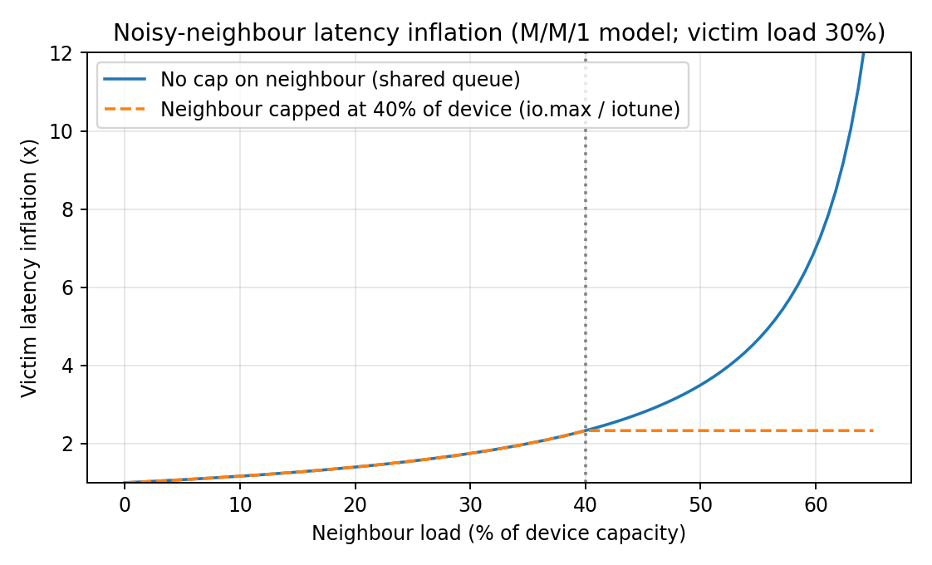
Figure 6: Noisy-neighbour latency inflation versus neighbour load (M/M/1 model). Overlay measured p95 ratios for the three approaches.

9.4 Analysis script (analyze.py)
import pandas as pd, numpy as np, matplotlib.pyplot as plt
df = pd.read_csv('results.csv', names=['approach','n','rep','metric','inst','value'])
df['value'] = pd.to_numeric(df['value'], errors='coerce'); df = df.dropna()
# mean over instances in each run, then mean and SD over repetitions
g = df.groupby(['approach','n','rep','metric']).value.mean().reset_index()
s = g.groupby(['approach','n','metric']).value.agg(['mean','std']).reset_index()
s.to_csv('summary.csv', index=False); print(s.to_string())

# ---- model calibrated on the n = 1 measurement of each approach (edit LINK_GBPS)
LINK_GBPS = 25 * 0.975 # usable link rate of YOUR test network
fig, ax = plt.subplots(figsize=(6.6, 4)); rows = []
for a in ['kvm', 'docker', 'gvisor']:
d = s[(s.approach == a) & (s.metric == 'net')].sort_values('n')
if d.empty: continue
t_path = d[d.n == 1]['mean'].iloc[0] # per-instance path limit
pred = [min(t_path, LINK_GBPS / n) for n in d.n]
ax.errorbar(d.n, d['mean'], yerr=d['std'], fmt='o-', capsize=3, label=a + ' measured')
ax.plot(d.n, pred, '--', label=a + ' model')
for n, m, p in zip(d.n, d['mean'], pred):
rows.append((a, n, p, m, 100 * (m - p) / p))
ax.set_xscale('log', base=2); ax.set_xlabel('Instances n'); ax.set_ylabel('Per-instance throughput (Gbps)')
ax.grid(alpha=.3); ax.legend(); fig.tight_layout(); fig.savefig('fig5_throughput.png', dpi=170)
err = pd.DataFrame(rows, columns=['approach','n','model','measured','error_pct'])
print(err.to_string()); print('MAPE %:', err.error_pct.abs().mean())

# ---- noisy neighbour: file noisy.csv with columns approach,case,p95_ms,rep
try:
nz = pd.read_csv('noisy.csv'); t = nz.groupby(['approach','case']).p95_ms.agg(['mean','std']).unstack()
t.plot.bar(y='mean', yerr=t['std'], capsize=3, figsize=(6.6, 4)); plt.ylabel('p95 latency (ms)')
plt.tight_layout(); plt.savefig('fig6_noisy.png', dpi=170)
except FileNotFoundError: pass

TASK 10: Compare Theory with Experiment
How the comparison must be done. Because the lab is smaller than EduCloud, compare trends and ratios rather than absolute EduCloud numbers: calibrate each model parameter on the n = 1 run (for example T_path from the n = 1 network result), predict n = 2…16, then compute the error err = (measured − predicted)/predicted × 100% and the mean absolute percentage error (MAPE). A result within ±15% is a good agreement, 15–30% is acceptable but needs an explanation, above 30% means a model term is missing.

10.1 Predictions to test (from Tasks 3 and 4)
# | Model prediction | Measured value (fill) | Error % | Plausible cause if the error is large
1 | CPU-bound degradation: KVM about 3–6%, Docker about 0–1%, gVisor about 1% for compute-only, about 9% for syscall-heavy |  |  | Nested virtualization (each exit costs several times more), laptop turbo/thermal throttling, SMT sharing, scheduler placement
2 | Network at n = 1 order: Docker > KVM > gVisor; all converge to link/n once n exceeds B_eff/T_path (n ≥ 2 for KVM and Docker, n ≥ 9 for gVisor) |  |  | Loopback or Wi-Fi instead of 25 GbE; iperf3 CPU limits; TSO/GRO offload differences; bridge/NAT configuration
3 | Disk IOPS: per-instance ceiling KVM 150k, Docker 400k, gVisor 40k (EduCloud), knee when 700k/n < ceiling; ranking should hold in the lab at lower values |  |  | Laptop SSD (SATA or NVMe with a different queue depth), host page cache (missing --direct=1), virtio cache mode, filesystem under test
4 | Memory per idle instance: KVM about 0.3 GB above its guest allocation, Docker about 20 MB, gVisor about 150 MB |  |  | Guest page cache, KSM, docker stats excludes kernel memory, Sentry heap growth
5 | Start-up time: containers well under VMs (VM boots a kernel) |  |  | Cached image layers, cloud-init delays, disk contention while starting 16 at once
6 | Noisy neighbour: victim p95 inflation about 7× without a cap and about 2.3× with a 40% cap (device-level model); containers expected to show additional inflation from shared kernel structures |  |  | Queue depth and neighbour intensity differ from the model; SSD controller caches; CPU frequency sharing
7 | Disabling SMT: about −20% throughput for CPU-bound parallel work, little change for a single-threaded test |  |  | Single-threaded benchmark does not use sibling threads; laptop power limits

10.2 How to interpret the results
- Do the degradation trends agree with the model? The model predicts that (i) the ordering of per-instance overhead is gVisor > KVM > Docker for syscall- and I/O-heavy work and nearly equal for compute work, (ii) degradation stays flat while u·r ≤ 1 and then rises as 1/(u·r) (the knee in Figure 2), and (iii) per-instance throughput follows B/n once the device saturates. State for each of the three which direction your data shows and where the knee appears (n where steal time first rises above 5%).
- Which approach scales better? Use the slope of throughput versus n and the start-up time at n = 16. The model predicts containers scale best in start-up time and memory (about 20 MB per instance), KVM scales predictably with strong isolation but has a larger fixed footprint, and gVisor scales like containers once the device saturates but pays at low n. If your data contradicts this, identify which assumed constant (t_exit, t_gv, t_pkt) was wrong and recompute it from the measurements.
- Quantitative differences and causes. For each row in Table 10.1 compute err and write one sentence on the dominant cause. Expect the largest errors where the model has no term: nested virtualization (inflates VM-exit cost, so the KVM CPU result will probably be worse than predicted), laptop thermal behaviour, host page cache, Wi-Fi or loopback networking, and hypervisor scheduler behaviour (CFS wake-up latency is not in the model).
- Do the measurements change the Task 5 conclusions? Apply these rules: if uname -r is identical inside Docker and on the host, threat 1 exposure for approach B stays high (confirmed); if gVisor reports a different kernel, the boundary-1 claim is confirmed; if the noisy-neighbour inflation for containers is clearly larger than for VMs, this strengthens the case for VM boundaries for the SIS; if /sys/devices/system/cpu/vulnerabilities/ shows 'SMT vulnerable' on your CPU, the case for M1 is confirmed; if gVisor's measured overhead at your syscall rate exceeds 10%, it is ruled out for the SIS database (as in Task 6).
Conclusion to write after the experiment: one paragraph stating (1) MAPE for network and disk models, (2) the biggest single deviation and its cause, (3) whether the ranking of the three approaches matched the prediction, and (4) which Task 5 conclusion was confirmed or modified.

TASK 11: Recommend and Defend the Final Architecture

11.1 Recommendation: a hybrid with a VM boundary for the SIS and containers for the LMS
Workload | Recommended architecture | Reason
SIS and exam portal (database and application) | A: KVM VMs on a dedicated host pool, SMT off, signed golden images, encrypted live migration, micro-segmented network | Highest sensitivity (confidentiality, integrity of student records). Strong hardware boundary with a small host attack surface; passes 10% SLO to 33 VMs/host at u = 0.5 (Task 3); gVisor ruled out by its 10× syscall cost and 3 Gbps ceiling; shared-kernel containers fail the isolation constraint (Task 6, P1)
LMS (web tier) | B: hardened containers (runc, rootless, seccomp default, read-only root, cgroup limits) running inside KVM worker VMs (Kubernetes/OpenStack node VMs) | Containers give fast start-up and density (35/host at u = 0.5, o = 0.15%), elastic scaling for registration and exam weeks; the VM underneath keeps a hardware boundary between departments and the SIS
Internal research | Containers or VMs on a separate pool, lendable to the SIS/LMS pools in the peak week | Lower sensitivity, high density (59–62/host at normal load), lower cost
Less trusted or external tenants (Task 12) | C: gVisor or Kata inside KVM VMs, or KVM VMs on their own pool | Adds a second boundary where tenants are not trusted

11.2 Why it beats the alternatives
All-containers (B) gives the best density and speed, but the shared kernel fails the SIS isolation constraint and the audit finding on shared hosts. All-VMs (A) satisfies isolation but leaves the LMS with slow scale-out and the large per-VM footprint and kernel-patching burden (400 guest kernels). All-gVisor (C) has the lowest escape exposure among containers but violates the SLO for syscall-heavy services above 55,555 syscalls/s. The hybrid assigns each workload the cheapest approach that satisfies its own constraints, which is exactly the optimisation in Task 6.

11.3 Performance, security posture and residual risk
- Modelled performance: SIS pool: o_A = 4.5%, 33 VMs/host at u = 0.5 (22 at 0.75); LMS containers: o = 0.15%, 35/host; network: KVM 13.3 Gbps per VM at n = 1 falling to B_eff/n; capacity at 4:1 is steal-free only if u ≤ 0.25. Experimentally observed: quote your Table 9.1–9.3 values here (CPU degradation, network at n = 8, noisy-neighbour inflation with and without cap, SMT-off cost) and state whether each is within the ±15% band of the model.
- Security posture: threats 1, 2, 4, 5 and 6 reduced from High/Medium to Low/Medium by M1, M2, M4, M5 and M6 (risk index 14 → 7 for the SIS pool). Residual risks: unknown hypervisor or QEMU vulnerabilities, cross-core cache side channels, a compromised management plane or signing key, and misconfiguration. Controls: patch SLAs, monitoring, restricted management network, regular audit.

11.4 Operational costs
Area | Cost under the recommendation
Patching | VM guests: one kernel per VM (hundreds to thousands); reduce by rebuilding golden images and replacing VMs in rolling fashion. Containers: one host kernel per host plus image rebuilds. Hosts are patched by live migration inside the pool (needs N+1 headroom and 10 Gbps migration bandwidth).
Image management | One signed registry/catalogue; image TTL and automatic scanning; no free copying between teams (audit finding).
Migration | Pre-copy time T = M/(B_mig − D); for an 8 GB SIS VM at D = 0.5 GB/s it is 10.7 s; encrypted migration uses about 1% host CPU.
Monitoring | Steal time (alert above 5%), exit rate, p95 latency, per-tenant I/O; dashboards per pool.
Hardware | SMT off costs 20% capacity on the SIS pool; dedicated pools cost about 22% more hosts than a fully pooled design.

11.5 Limitations, trade-offs and growth to several thousand instances
Limitations: assumed constants (t_pkt, q_path, t_gv, e, σ) must be validated; lab results are small-scale and may include nested virtualization; the 10% SLO is one possible target. Growth: hosts = Σ_c ⌈N_c / n_c⌉. For 4,000 instances, half critical (u = 0.5, n = 33) and half batch (u = 0.25, n = 59): ⌈2000/33⌉ + ⌈2000/59⌉ = 61 + 34 = 95 hosts (about 6× today). The architecture remains practical if (i) hosts are managed by an orchestrator (OpenStack/Kubernetes) with immutable signed images instead of hand-patched VMs, (ii) the network uses VXLAN/VRF segmentation with automation, (iii) storage scales out (for example Ceph or NVMe-oF) with per-pool keys, and (iv) the number of pools stays small (three or four) so the operational complexity does not grow with the number of tenants. The weakest point is per-VM management at that scale, which the immutable-image workflow addresses.

TASK 12: Day-4 Design Challenge: Re-evaluate and Adapt the Design

A. Impact Analysis
- What changed: the platform changes from an internal, mostly trusted, latency-sensitive transactional system to a shared platform with external, less-trusted tenants running hours-long, I/O- and network-intensive Spark/Hadoop jobs beside the SIS, plus a 3× registration peak, live-migration patching, and a regulation demanding demonstrable isolation.
- Assumptions that no longer hold: (1) trusted tenants: external code can attempt escape, side channels and spoofing; (2) workload mix: steady batch load now permanently occupies disk and NIC; (3) I/O profile: sequential multi-Gbps shuffle traffic instead of small transactional requests; (4) peak behaviour: u rises from 0.5 to 0.75 for SIS/LMS (3× normal load of u = 0.25); (5) migration: live migration is routine, so migrating memory images across tenants is now a confidentiality risk.
- Performance impact of mixing: a shared 25 Gbps NIC behaves like a queue with latency proportional to 1/(1 − ρ). If four Spark VMs at 5 Gbps (20 Gbps) share a NIC with 4.4 Gbps of SIS traffic, ρ = 24.4/24.4 = 1.0: the queue is unbounded and SIS p95 latency collapses. Keeping ρ ≤ 0.7 (3.3× service time) allows 17 Gbps in total, so at most two Spark VMs per host. The same applies to the NVMe device and the last-level cache.
- Threat-model impact: the attacker is now an authenticated tenant with root inside a VM or container on the same hardware. Threats 1, 2, 5 and 6 move from a theoretical to a practical exposure, and the regulation turns isolation into an evidence requirement (separate hosts, networks, storage and keys that can be shown to an auditor).

B. Evaluation of the Original Design
- Performance targets (Task 3 model, new workload). Original design: 4 hosts for 120 SIS+exam VMs = 30 per host. At u = 0.75: r = 30 × 4/64 = 1.875, u·r = 1.41, C_eff = 0.955 × (1/1.41) = 0.68, so degradation is 32%, far above the 10% SLO. N_max at u = 0.75 is 22 VMs per host (Task 3), so the SIS+exam pool needs ⌈120/22⌉ = 6 hosts, the LMS ⌈80/22⌉ = 4 hosts. The same dedicated pool cannot absorb the big-data load.
- Big-data VMs: a Spark VM of 64 GB fits (512 − 16)/64.3 = 7 per host. Their live migration is expensive: with a dirty rate D = 1.0 GB/s, T = 64/(1.25 − 1.0) = 256 s, and D ≥ 1.25 GB/s never converges, so live migration is not a viable patching method for the batch pool.
- Isolation adequacy: the original design shares NICs, datastores, the migration network and keys across tenants. That is adequate for trusted internal departments but not for external tenants, and it cannot be demonstrated to an auditor. A dedicated SIS pool already satisfies host-level isolation, but only if no external VM can share its hosts, storage or network.
- Could another architecture do better? gVisor for Spark: escape risk is low, but Spark is syscall-, file- and network-heavy, so the 2.0 µs syscall cost, Gofer path and 3 Gbps netstack ceiling would break the throughput target (fails the Task 3 break-even). Containers (runc): highest density, but a shared kernel for untrusted tenants is unacceptable under the regulation. Bare-metal-as-a-service for the external pool: best isolation and I/O but least flexible and no live migration. KVM VMs on a separate pool with SR-IOV: a good balance, chosen below.

C. Adaptation or Redesign
Decision: MODIFY. The core (KVM VMs for the SIS, hardened containers inside VMs for the LMS, the Task 6 formulation) stays valid; what changes is tenancy structure and the I/O path. A full redesign is not needed because the model and constraints already cover the new case with different parameters (u = 0.75, 64 GB VMs, untrusted tenants).
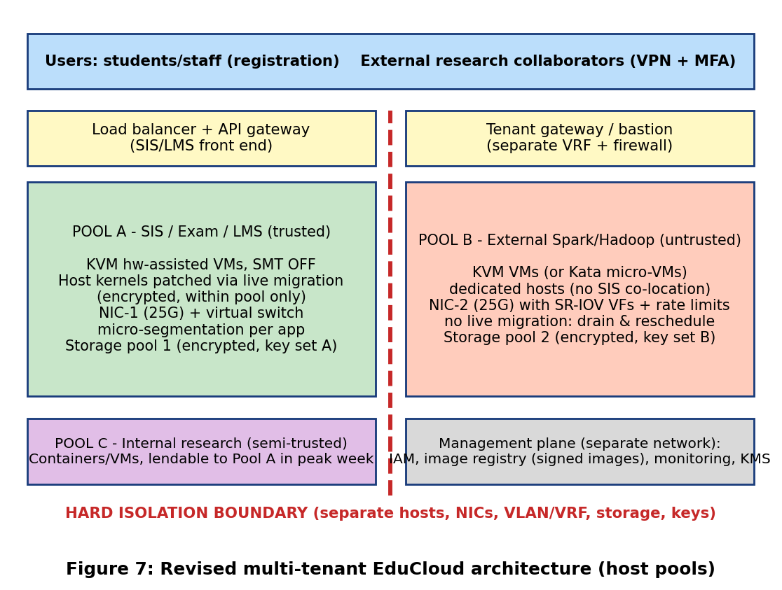
- Tenant separation by host pools: Pool A (SIS/exam/LMS, trusted), Pool B (external Spark/Hadoop, untrusted), Pool C (internal research, lendable to Pool A in registration week after being cleaned and SMT-off hardened). No host, NIC, storage pool, key set or migration network is shared between A and B.
- Stronger isolation for external workloads: KVM VMs (or Kata micro-VMs under Kubernetes) with SELinux/sVirt, IOMMU, per-tenant VLAN/VRF, per-tenant encryption keys; container-only execution of external code is not allowed.
- Dedicated NIC with SR-IOV for the data-intensive jobs: Pool B uses NIC-2 with SR-IOV virtual functions (rate-limited, VLAN-tagged, spoof-check on), bypassing the virtual switch (path cost about 0.3 µs per packet, assumed). 25 Gbps/7 VMs ≈ 3.5 Gbps guaranteed per Spark VM. Pool A stays on NIC-1, so ρ on NIC-1 stays within the 0.7 limit. Because SR-IOV bypasses OVS micro-segmentation, compensate with VF VLAN filters and upstream firewalling.
- Encrypted migration policy: live migration only inside Pool A, over a dedicated 10 Gbps network with TLS/IPsec (about 1% host CPU); Pool B is patched by drain and reschedule (Spark task retries), never by live migration. An 8 GB SIS VM migrates in 10.7 s at D = 0.5 GB/s.
- Effect on density: SIS pool N_max 33 → 22 per host (−33%) in the peak week; Spark VMs 7 per host (memory-bound); research 59 per host.
- Effect on throughput: Spark gets rate-limited, predictable bandwidth; SIS latency no longer depends on batch traffic; SIS network cap at n = 1 is 12 Gbps per VM after micro-segmentation.
- Effect on attack surface: removes shared-host, shared-network, shared-storage and shared-migration paths between external and student-record tenants; adds SR-IOV/NIC firmware and one more gateway to defend.

D. Evidence-Based Defence
Evidence | Result | What it shows
Capacity at peak (u = 0.75) | Pool A: ⌈120/22⌉ + ⌈80/22⌉ = 6 + 4 = 10 hosts; Pool B: ⌈28/7⌉ = 4 hosts (28 Spark VMs) | Peak demand 14 hosts; with one spare host for each of A and B (N+1 for patching/migration), 16 hosts: exactly today's cluster
Off-peak capacity (u = 0.25) | Pool A: ⌈120/59⌉ + ⌈80/59⌉ = 3 + 2 = 5 (+1 spare); Pool B: 4 (+1); research 4 = 15 hosts | Fits in 16 hosts; research is paused or lent out for the 2–3 peak weeks
Isolation cost | Segregated with N+1 per pool = 16 hosts versus one shared pool with a single N+1 = 15 hosts | Demonstrable isolation costs about 1 host (+7%) at peak, no new purchase
Noisy-neighbour experiment (Tasks 8–10) | Model: victim p95 inflation 7× uncapped versus 2.3× with a 40% cap; insert your measured ratios for A, B, C | Why external batch load must not share NIC or datastore with the SIS, and why caps are a fallback, not a substitute for separation
Mitigation experiment (SMT off) | Model −20% throughput, SIS pool +1 host; insert your measured Table 9.3 values | Whether the cost of M1 is acceptable for the SIS (it is, if the measured loss is near the model value)
Network on shared NIC | ρ = 1.0 with 4 Spark VMs, but ρ ≤ 0.7 requires ≤ 17 Gbps in total | Dedicated NIC with SR-IOV is required, not optional
Live migration | SIS 8 GB: 10.7 s (D = 0.5 GB/s); Spark 64 GB: 256 s (D = 1.0), not convergent at D ≥ 1.25 | Migration only inside Pool A; drain and reschedule for Pool B
Mitigations (Task 7) | Risk index for the SIS pool 14 → 7; external pool on separate hosts removes threats 1, 2, 5 and 6 from the SIS attack paths | Regulation evidence: separate hosts, NICs, storage and keys

Trade-offs. Complexity rises (three pools, two NIC profiles, SR-IOV configuration, key management); idle capacity increases because pools cannot share freely; research jobs are preempted in the peak week; SR-IOV limits live migration and bypasses virtual-switch controls; staff need skills in KVM tuning and orchestration; vendor lock-in is low because KVM, SR-IOV, VXLAN and Kubernetes are open standards. Final decision: MODIFY the original hybrid by adding host-pool separation, a dedicated SR-IOV NIC for the batch tenant, a pool-restricted encrypted migration policy and a temporary borrowing rule for the registration peak. It meets the 10% SLO at 3× load, keeps live-migration patching for the SIS, provides auditable isolation for the new regulation, and fits the existing 16 hosts, subject to confirmation by the measurements in Tasks 9 and 10.

